Variable Types in Java
int dataVariable = 10;
Above statement in Java represents that I have created a 'int' variable and assigned a value 10 to it, behind the scenes what actually happens at runtime a 4 byte area will be reserved in memory and value 10 will be stored. We do not need to deep dive in this memory allocation concepts now. However as we progress we will gradually understand the aspect and importance of memory allocation in Java.
Coming back to actual topic which is variable types in Java.
- Local Variable
-- A variable which is declared inside the method is called local variable.
- Instance Variable
-- A variable which is declared inside the class but outside the method and is not defined static.
- Static Variable
-- A variable which is declared as static inside the class.
Note:- A variable can be declared as static only inside the class not inside the method, if you attempt to declare a variable as static inside the method it will result in compilation error. Also we will cover topic related to static keyword detail ahead, so keep your questions safe when we touch static keyword ahead.
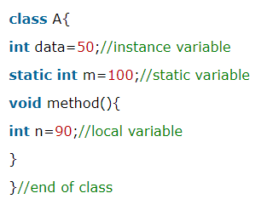
Data Types in Java
int dataVariable = 10;
int = Data Type of variable
dataVariable = Name of the variable
10 = Assigned value

In Java, we can primarily classify Data Types into below two categories:-

  - Primitive Data Type
  - Non Primitive Data Type

Primitive Data Type
Below table lists down the Primitive Data Types in Java.
Data Type | Default Value | Default Size
boolean | FALSE | 1 bit
char | '\u0000' | 2 bytes
byte | 0 | 1 byte
short | 0 | 2 bytes
int | 0 | 4 bytes
long | 0L | 8 bytes
float | 0.0f | 4 bytes
double | 0.0d | 8 bytes

Non Primitive Data Type
Any other Data Type which is not mentioned in Primitive Data Type is referred as non-primitive data type in Java e.g. String, Integer, BigDecimal etc
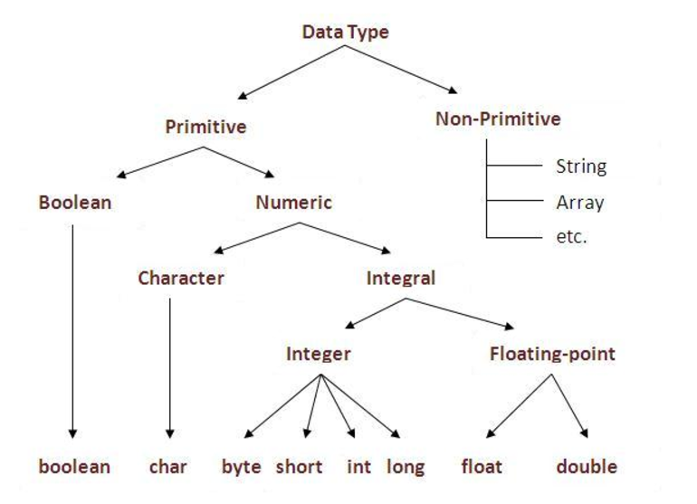

\\\\\

Note:- There is topic related to type casting related to data type which will be covered later, once simple basics of Java are in place.

Basic Operators in Java

Operator | Usage
+ | Addition
- | Subtraction
* | Multiplcation
/ | Division
&& | Logical AND
|| | Logical OR
% | Mod
== | To Test Equality
!= | To Test Non Equality

